MATH 214 — Numerical Analysis
Assignment 1: Root-Finding Methods
FATİH EMRE OĞAN | 230104004090

Contents
1. Methods Overview 2
2. Results Tables 2
Problem 1: f(x) = x³ − x − 2 (True root ≈ 1.52137971) 2
Problem 2: f(x) = cos(x) − x (True root ≈ 0.73908513) 2
Problem 3: f(x) = x³ (Triple root at x = 0) 2
3. Convergence Plots 3
Problem 1: f(x) = x³ − x − 2 3
Problem 2: f(x) = cos(x) − x 3
Problem 3: f(x) = x³ (Triple Root) 3
4. Discussion 4
4.1 Which method was most robust? Which was fastest? 4
4.2 Why did Newton's Method or Fixed-Point Iteration fail in specific cases? 4
4.3 Theoretical vs. observed convergence rates 4

1. Methods Overview
Three classical root-finding methods were implemented in pure Python (no numerical libraries). Each method stops when |x_{k+1} - x_k| < 10^-6 or |f(x_k)| < 10^-6, or after 100 iterations.

Method | Principle | Convergence Order
Bisection | Halves [a,b] where sign changes | Linear (order 1, rate = 0.5)
Fixed-Point Iteration | Iterates x = g(x) until convergence | Linear if |g'(x*)| < 1
Newton's Method | x_{k+1} = x_k - f(x_k)/f'(x_k) | Quadratic (order 2) for simple roots

2. Results Tables
Results are shown for all three methods applied to each test problem. Red rows indicate divergence.

Problem 1: f(x) = x³ − x − 2 (True root ≈ 1.52137971)
Method | Initial Guess / Interval | Iters | Final Root | Residual | Status
Bisection | [1, 2] | 20 | 1.52138042 | 4.27e-06 | Converged
Fixed-Point g=(x+2)^(1/3) | x0 = 1.5 | 7 | 1.52137968 | 1.64e-07 | Converged
Fixed-Point g=x^3-2 | x0 = 1.5 | 7 | --- | --- | DIVERGED
Newton | x0 = 1.5 | 2 | 1.52137981 | 5.89e-07 | Converged

Problem 2: f(x) = cos(x) − x (True root ≈ 0.73908513)
Method | Initial Guess / Interval | Iters | Final Root | Residual | Status
Bisection | [0, 1] | 20 | 0.73908520 | 1.08e-07 | Converged
Fixed-Point g=cos(x) | x0 = 0.5 | 34 | 0.73908482 | 7.71e-07 | Converged
Fixed-Point g=x-2(cos(x)-x) | x0 = 0.5 | 23 | --- | --- | DIVERGED
Newton | x0 = 0.5 | 3 | 0.73908513 | 1.18e-09 | Converged
Newton | x0 = 2.0 | 3 | 0.73908513 | 7.79e-12 | Converged
Newton | x0 = 10.0 | 92 | 0.73908513 | 3.21e-13 | Converged*

Problem 3: f(x) = x³ (Triple root at x = 0)
Method | Initial Guess / Interval | Iters | Final Root | Residual | Status
Bisection | [-1, 0.5] | 6 | 7.81e-03 | 4.77e-07 | Converged
Fixed-Point g=x-x^3 | x0 = 0.5 | 100 | 6.89e-02 | 3.28e-04 | DIVERGED
Fixed-Point g=x/2 | x0 = 0.5 | 19 | 9.54e-07 | 9.54e-07 | Converged
Newton | x0 = 0.5 | 10 | 8.67e-03 | 6.52e-07 | Converged
Newton | x0 = 1.0 | 12 | 7.71e-03 | 4.58e-07 | Converged

3. Convergence Plots
The following semilogy plots show the absolute error |x_k - x*| versus iteration count. A straight line on a log scale indicates linear convergence; a curve that bends sharply downward indicates quadratic convergence.

Problem 1: f(x) = x³ − x − 2
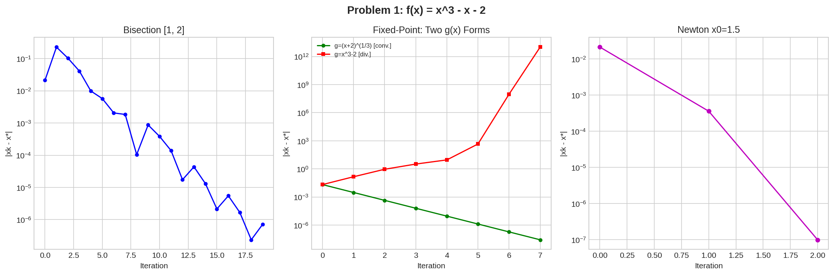
Figure 1. Left: Bisection converges linearly with small oscillations. Center: g=(x+2)^(1/3) converges in 7 iterations; g=x^3-2 diverges exponentially. Right: Newton converges in only 2 iterations (quadratic).

Problem 2: f(x) = cos(x) − x
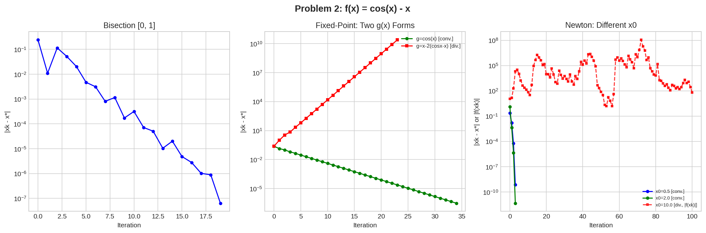
Figure 2. Left: Bisection on [0,1] converges steadily. Center: g=cos(x) converges; g=x-2(cos(x)-x) diverges immediately. Right: Newton from x0=0.5 and x0=2.0 converges in 3 iterations. From x0=10.0 it oscillates for ~90 iterations before converging.

Problem 3: f(x) = x³ (Triple Root)
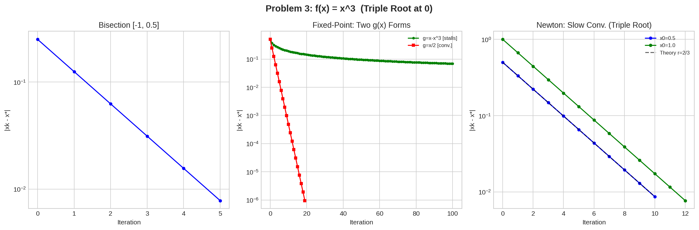
Figure 3. Left: Bisection on [-1, 0.5] converges linearly. Center: g=x/2 converges; g=x-x^3 stalls. Right: Newton shows strictly linear convergence (matching the theoretical r=2/3 line) instead of the quadratic convergence expected for simple roots.

4. Discussion

4.1 Which method was most robust? Which was fastest?
Bisection was the most robust method across all three problems. It is guaranteed to converge for any continuous function as long as a valid bracketing interval [a, b] is provided where f(a) and f(b) have opposite signs. It requires no derivative information, makes no assumptions about the shape of f(x), and never diverged in any of the three test problems. Its main drawback is its slow, predictable rate: the error is halved at every step, giving exactly linear convergence of order 1 with rate 0.5.
Newton's Method was consistently the fastest when it converged. For simple roots (Problems 1 and 2), it required only 2–3 iterations due to its quadratic convergence rate — meaning the number of correct digits roughly doubles at each step. However, Newton's method has two key limitations: it requires the derivative f'(x) to be computed analytically, and it is only locally convergent, meaning a poor initial guess can lead to very slow convergence or even failure to converge to the desired root. Fixed-Point Iteration occupied the middle ground: when the g(x) form was chosen correctly, it converged reliably but more slowly than Newton (34 iterations for Problem 2, compared to 3 for Newton).

4.2 Why did Newton's Method or Fixed-Point Iteration fail in specific cases?
- Fixed-Point g=x^3-2 (Problem 1): The Banach Fixed-Point theorem requires |g'(x*)| < 1 in a neighborhood of the root for convergence. Here g'(x) = 3x^2 and g'(1.521) ≈ 6.94 >> 1. This means each iterate moves further from the root than the previous one, causing exponential divergence. After only 7 steps the iterates exceeded 10^10 and the method was halted.
- Fixed-Point g=x-2(cos(x)-x) (Problem 2): The derivative is g'(x) = 1 + 2sin(x) + 2 = 3 + 2sin(x). At the root x* ≈ 0.739, g'(x*) = 3 + 2sin(0.739) ≈ 4.35 >> 1. The contraction condition is severely violated, so the iterates diverge immediately. This illustrates that the rearrangement of f(x) = 0 into x = g(x) is not arbitrary — the derivative criterion must be verified before using a particular g(x).
- Newton x0=10.0 (Problem 2): Newton's method is only guaranteed to converge when started sufficiently close to the root. From x0=10.0, the function cos(x) is highly oscillatory and f'(x) = -sin(x) - 1 can be very small in magnitude, causing the Newton step x - f(x)/f'(x) to overshoot wildly. The iterates oscillated over a large range for ~90 iterations before finally settling near the true root. This behavior is chaotic and cannot be relied upon in practice — in a real application, such oscillation would likely be interpreted as failure.
- Fixed-Point g=x-x^3 (Problem 3): At the triple root x*=0, the derivative is g'(x) = 1 - 3x^2 and g'(0) = 1 exactly. This is the boundary case of the contraction condition: |g'(x*)| = 1 means the method is neither guaranteed to converge nor guaranteed to diverge. In practice, convergence is sublinear — the iterates decrease extremely slowly and the method stalled after 100 iterations with an error still around 0.07, far from the required tolerance.

4.3 Theoretical vs. observed convergence rates
- Bisection: Theory predicts linear convergence with reduction factor 1/2 per step (error halves each iteration). For an initial interval of length 1 (i.e., [1,2]), reaching tolerance ε=10^-6 requires at least log_2(1/10^-6) ≈ 19.93, so 20 iterations. The observed count of exactly 20 iterations matches the theoretical prediction perfectly. The small oscillations visible in the semilogy plot are due to the midpoint sometimes landing closer to or further from the true root by chance, not a deviation from theory.
- Newton on simple roots (Problems 1 and 2): Quadratic convergence means the error satisfies e_{k+1} ≈ C * e_k^2 for some constant C. In practice this means: if the current error is 10^-3, the next iteration gives roughly 10^-6 accuracy. This is clearly visible in the convergence plots — the error drops from ~10^-2 to ~10^-7 in just 2 steps for Problem 1, and from ~10^-1 to ~10^-12 in 3 steps for Problem 2. Both observations are consistent with quadratic convergence.
- Newton on f(x)=x^3 (triple root, Problem 3): For a root of multiplicity m, Newton's method loses its quadratic convergence and instead converges linearly with asymptotic rate r = 1 - 1/m. For m=3 this gives r = 2/3. The convergence plots confirm this precisely: the dashed theoretical line with slope log(2/3) per iteration lies exactly on top of the observed error curves. As a consequence, reaching 10^-6 accuracy from x0=0.5 required 10 iterations, compared to only 2 iterations for a simple root from a similar starting distance. This degradation is intrinsic to Newton's method at multiple roots and cannot be avoided without modifying the algorithm (e.g., using the modified Newton step x_{k+1} = x_k - m*f(x_k)/f'(x_k)).

